**ASSIGNMENT 2 FRONT SHEET**

|  |  |  |  |
| --- | --- | --- | --- |
| **Qualification** | **BTEC Level 5 HND Diploma in Computing** | | |
| **Unit number and title** | Unit 06: Managing a Successful Computing Project | | |
| **Submission date** | Wednesday, 25 December 2019, 11:59 PM | **Date Received 1st submission** | Wednesday, 25 December 2019, 11:59 PM |
| **Re-submission Date** |  | **Date Received 2nd submission** |  |
| **Student Name** | Pham Van Minh Duc | **Student ID** | GCD17053 |
| **Class** | GCD0703 | **Assessor name** | Srikanth Raju Kandukuri |
| **Student declaration**  I certify that the assignment submission is entirely my own work and I fully understand the consequences of plagiarism. I understand that making a false declaration is a form of malpractice. | | | |
|  |  | **Student’s signature** |  |

**Grading grid**

|  |  |  |  |  |  |
| --- | --- | --- | --- | --- | --- |
| P5 | P6 | P7 | M3 | M4 | D2 |
|  |  |  |  |  |  |

|  |  |  |
| --- | --- | --- |
| **❒ Summative Feedback: ❒ Resubmission Feedback:** | | |
| **Grade:** | **Assessor Signature:** | **Date:** |
| **IV Signature:** | | |

# Table of Contents

Table of Contents 4

Table of Figures 5

Table of Table 6

Introduction 7

P5 and M3. Analyze research and data with appropriate tools and techniques. 8

1. Analyze data research with the necessary tools 8

2. Evaluate the selection of appropriate and accurate tools and techniques to support and demonstrate recommendations. 14

P6 and D2. Convey appropriate recommendations as a result of research and data analysis to draw valid and meaningful conclusions. 16

P7 and M4. Reflect on the value of undertaking the research to meet stated objectives and own learning and performance. 18

1. Reflect on the value of research so that you can meet all the stated goals as well as learning and all your performance. 18

2. Assess the value of the project management process and use quality research to meet its goals, as well as assist in learning and project performance 20

2.1 Performance review 20

2.2 Sample table for Digital Wellbeing project diary 21

Word of the author 23

# Table of Figures

Figure 1 Email customers to participate in the survey 8

Figure 2 Satisfaction level when using your application 9

Figure 3 In your opinion, this application is suitable for all ages? 9

Figure 4 User answered question 10

Figure 5 Charts of customer satisfaction 10

Figure 6 Charts of customer satisfaction 11

Figure 7 User answered question 11

Figure 8 User answered question 12

Figure 9 User answered question 12

Figure 10 Detailed chart of customers who want to add new functionality 13

Figure 11 The age of the user when using Digital Wellbeing 13

# Table of Table

Table 1 Sample table for Digital Wellbeing project diary 23

# Introduction

When I have completed the research project and have answered the company's problems, as well as presented the research results to the project management. Next, the board of directors asked me to write a brief report to the QA department so that I could reflect the entire process of the project, these requirements include: diaries, lessons learned from the project, Assess the importance of selecting tools, Assess the importance of the project management plan. The following is my assessment and writing of this report for Assignment2.

# P5 and M3. Analyze research and data with appropriate tools and techniques.

## 1. Analyze data research with the necessary tools

In order to carry out the project successfully, we have done a quantitative research in Assignment1, as well as the project based on all the appropriate tools to conduct the research as well as provide all the results are the way we have surveyed more than 400 customers currently using Digital Wellbeing, here are all the results we surveyed.

* **Email addresses of customers participating in the survey**

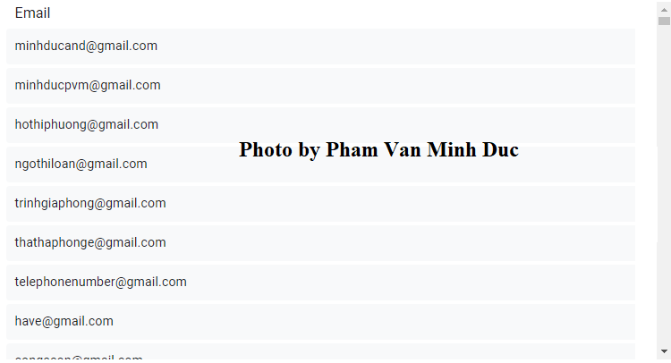

Figure 1 Email customers to participate in the survey

* **Sample survey table using Digital Wellbeing**
* Satisfaction level when using your application (1 = Very dissatisfied 5 = Very dissatisfied)

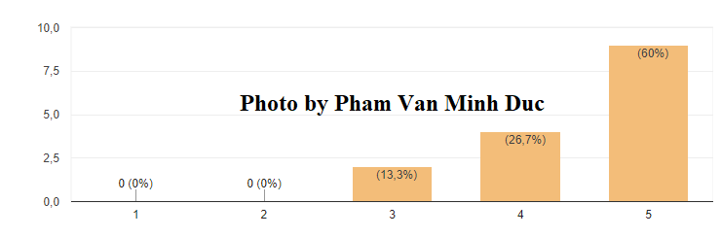  
  
  
  
  
  
  
  
  
  
  
  
**Figure 2 Satisfaction level when using your application**

* In your opinion, this application is suitable for all ages? (1 = Very dissatisfied 5 = Very dissatisfied)

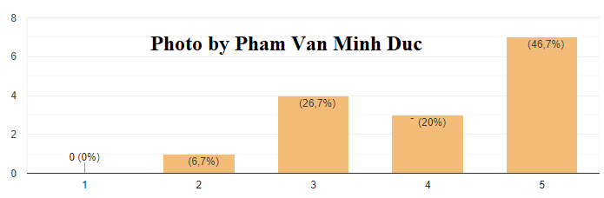

Figure 3 In your opinion, this application is suitable for all ages?

* The benefits when you use our application

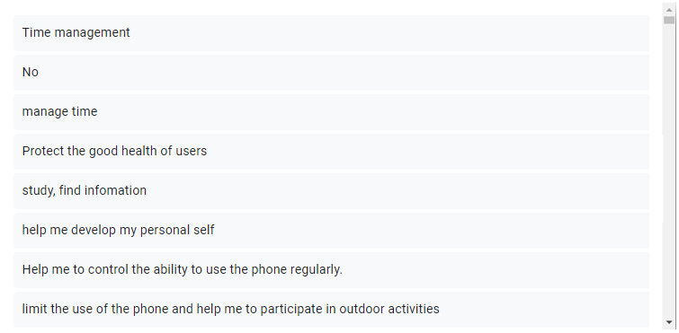  
  
  
  
  
  
  
  
  
  
  
  
  
  
  
  
  
  
  
  
  
  
  
  
  
Figure 4 User answered question

* Please indicate the level of satisfaction with the application use and satisfaction with our application design?

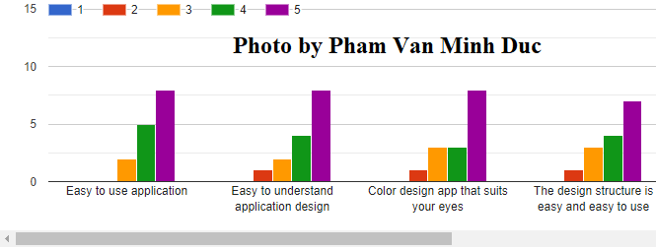  
  
  
  
  
  
  
  
  
  
  
  
  
  
  
  
  
  
  
Figure 5 Charts of customer satisfaction

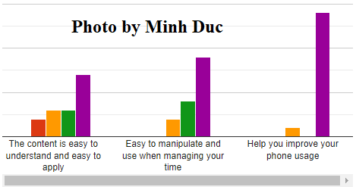  
  
  
  
  
  
  
  
  
  
  
  
  
  
  
  
  
  
Figure 6 Charts of customer satisfaction

* During the use, you have difficulty using our application

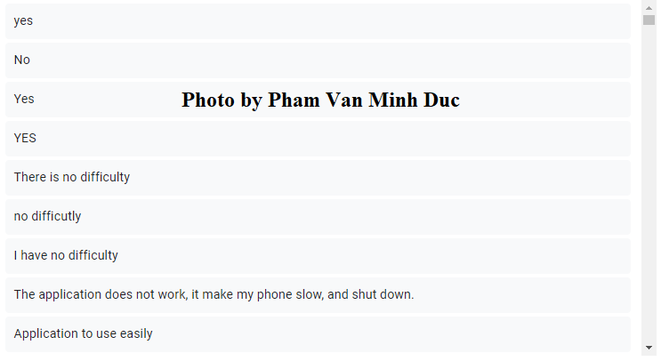  
  
  
  
  
  
  
  
  
  
  
  
  
  
  
  
  
  
  
  
  
  
  
  
  
  
  
  
Figure 7 User answered question

* Would you like us to add new functions to the application?

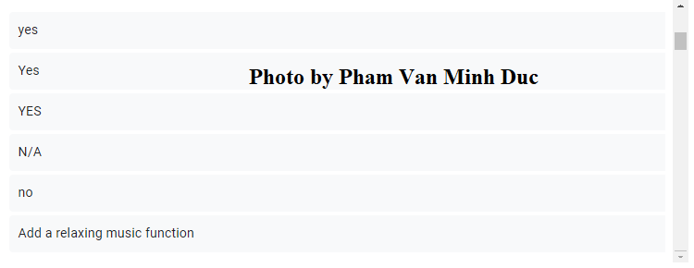  
  
  
  
  
  
  
  
  
  
  
  
  
  
  
  
  
  
  
  
Figure 8 User answered question

* Do you have any general feedback for our application

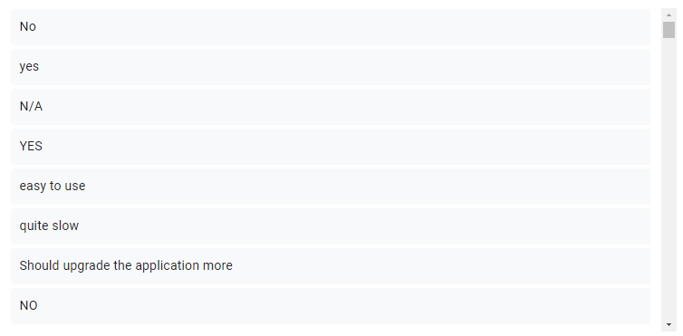  
  
  
  
  
  
  
  
  
  
  
  
  
  
  
  
  
  
  
  
  
  
  
  
  
Figure 9 User answered question

* Can you tell us more about your desired functions?

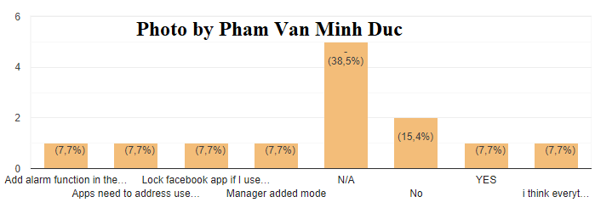  
  
  
  
  
  
  
  
  
  
  
  
  
  
  
  
  
  
Figure 10 Detailed chart of customers who want to add new functionality

* The age of the user when using Digital Wellbeing

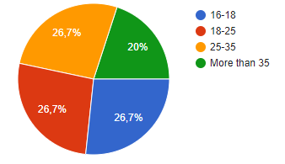  
  
  
  
  
  
  
  
  
  
  
  
  
  
  
  
  
  
  
  
Figure 11 The age of the user when using Digital Wellbeing

These are questions as well as customer answers after we progress to user surveys when they use Digital Wellbeing. Not only that, but we have also relied on all the right tools to conduct research. In addition, all user responses, as well as all graphs, show that users enjoyed using the Digital Wellbeing application.

## 2. Evaluate the selection of appropriate and accurate tools and techniques to support and demonstrate recommendations.

In order to help us evaluate the selection of appropriate tools and techniques as well as the accuracy to support and demonstrate recommendations, we can use some suitable tools such as Excel as well as all project management software from the database has been analyzed as well as surveyed more than 400 project customers by being able to record all specific data through each chart and comment by the customer, in the Digital Wellbeing project. Not only that, but it can also ensure that all information is accurate for each project information and that it will also be done correctly to meet all project customers.

In addition, we use a very popular online tool when we want to research as well as to develop a project, a Google survey tool called a form:

* **Google Forms** is the process of collecting data through a tool that includes a series of questions and prompts to receive feedback from the individuals for whom it is managed. In addition, it is a free tool for Google account holders; you can use the provided themes. This tool will allow you to create a new form and also have a collaborator feature. Not only that, Google form after the data has been collected, it will automatically create other tools with detailed statistics as well as completely free, it is very beneficial for research and development a project in the best way.

Not only that, when we use the Google Forms tool we will collect data correctly. Therefore, when using this survey tool from Google form we can develop Digital Wellbeing project much more accurately and easily.

Besides, when we apply customer survey tools with Google forms we are very beneficial in customer surveys and can research and develop projects more easily, as well as the following is the result: Research results for project development using Google form tools to be able to survey customers and we have collected 3 types of customers for project development research as follows:

* **Respondent 1**:
* Through all the surveys with each type of customer as well as all employees at the facility, there are some disagreements with the use of Digital Wellbeing and some interesting ideas when they use Digital Wellbeing. Specifically, with some of our first customers, we asked a question about the level of satisfaction with the application, some customers agreed with 60% of the project. In addition, they often use Digital Wellbeing to help them save a lot of time as well as reduce the use of phones too much which affects their health, as well as it can help them to be able to improve their health better health when participating in outdoor activities. Not only that, they agreed that they would recommend Digital Wellbeing to their families and friends.
* **Respondent 2**:
* The second customer disagrees with and doesn't like the app, thinking that daily use is a habit and it doesn't affect the health of the consumer or the user Digital Wellbeing when designed it is not appropriate. In addition, they also believe that Digital Wellbeing is not suitable for all ages, because they think that children or adults should use the phone more often to be able to update daily life news, just like them. Think that using your phone will never affect your health. Therefore, the use of the telephone is appropriate and Digital Wellbeing is not suitable for the commune. Not only that, this proportion accounts for 6.7% when we summarize.
* **Respondent 3**
* Third customers, they absolutely love the project and find it very attractive, as well as almost everything that they love Digital Wellbeing. Customers appreciate that Digital Wellbeing can manage their time as well as help them avoid using their phones too much and help them participate in outdoor activities more instead of spending too much time on using the daily phone. In addition, they are always suggesting us to add some new functionality in the app, and some other customers they have no idea about adding new functions, they think the current functions are more than enough or if adding new functions they will continue to support and use Digital Wellbeing, and this proportion accounts for about 38.5%.

# P6 and D2. Convey appropriate recommendations as a result of research and data analysis to draw valid and meaningful conclusions.

From all research data analysis work, as well as with the appropriate tools and techniques for the project, the following recommendations will be made as follows:

These are all tried and true methods so that all connections to external parties can be included together with all the documents to be able to communicate the results of the audit.

* **Complete the legal procedures:**
* When implementing the Digital Wellbeing project as one of the project managers, we are very reluctant to deal with all legal and project procedures. Therefore, the company is required to manage all of these before being able to implement any of the Digital Wellbeing projects in order to gain a lot of competitive advantages.
* **Enhance the appearance and updating of your website:**
* Photos, a study of all cases, updates, project stories, and even a final project report are required to be provided and updated on the website, Facebook page or possibly anyone. Any online community you join, including all non-profit management associations or any organized or supported management associations.
* **Human Resources:**
* In order to gain all the competitive advantage through all the programs in the project or company, a company must need human resources and have experience in all areas needed. Besides, from all my personal experience in recent Digital Wellbeing project management, I will also be able to recommend the company to be able to have an experienced workforce in all areas for the company, these people will most likely contribute everything to be able to complete the project within the required time
* **Complete budgets in the project:**
* To be able to complete a program in a project, a project manager needs to know all the resources needed in a project before executing a program in the project. Therefore, the company is required to set all budgets for the Digital Wellbeing project, in order to be able to complete the project successfully.
* **Developed as well as inform the press:**
* Press releases are also required to highlight the research findings as strongly as you have been able to discover, as well as research and distribution to all local newspapers, categories, Email lists in user community and all neighborhood organizations.
* **Release all official reports for the project:**
* When you have finished the project, you must complete all full reports and details of your research efforts in the project. In addition, you must also describe all your expected results and the logical models in your project, plan to be able to collect data, results as well as any suggestions or yes. What action could you have taken as well as planned to be able to perform in the Digital Wellbeing project.
* **Customer organization for the project:**
* Throughout all project processes, we have always encouraged all key investors in the project to work closely with all organizations as one of the very important parts of participation in the project. In addition, we should not stop until we can provide all the results in the project. Not only that, in addition to all the results for specific organizations, always remember to provide the most general results of the programs in the project that can provide all organizations with ideas as well as ways they can be compared to any others in their project team. This will most likely build a lot of goodwill for all the organizations for your organization, and it will most likely build a reputation for your project across the non-profit area profit. Not only that, but this will also help you create a lot of opportunities that will be very sure as well as there will be the return of all sponsors and it can also create a lot of The more needs for your project.
* **Products of the project:**
* With the Digital Wellbeing project, the final product is always required to focus primarily on the excessive use of the phone. In addition, it must also focus on taking care of the user's health, as well as helping users limit the excessive use of phones that affect their health.

# P7 and M4. Reflect on the value of undertaking the research to meet stated objectives and own learning and performance.

## 1. Reflect on the value of research so that you can meet all the stated goals as well as learning and all your performance.

When we study both research methods, qualitative and quantitative research, we can perform all the effects to be able to meet all the goals of the Digital Wellbeing project.

In addition, quantitative research has also revealed to us that almost all customers want a highly effective quality product. Not only had that but besides quantitative studies also showed us that the project can find the right place to implement the project successfully.

Also, analyzing all the work in the Digital Wellbeing project will most likely help the project manager to be able to set up all very specific tasks and details to be able to describe all the activities in the project, and it will be done in a clear, detailed and very complete manner. Therefore, according to a certain structure, the project manager will most likely complete all project tasks within a limited time within the project. Not only that, the Gantt chart in the project (Assignment1, page 33) has been assigned specific times as well as essential for each task in the project. Besides, the Gantt chart clearly states as well as specified real-time assignments to be able to perform all tasks in the Digital Wellbeing project, to enable project managers to complete the project almost all project tasks within the project's time limit.

**a) Issues to be overcome in the project survey.**

When we review the questions in the survey questionnaire, some of the issues that still need to be fixed include:

* The structure design in the survey table is irrational
* The question is a bit confusing
* The content of the question is repeated

**b)** **Manage projects in learning as well as done separately**

* **Negotiation skills:**
* When I was running the project, I had to contact many people and all the stakeholders and representatives in the Digital Wellbeing project many times. In addition, I also had a lot of ideas on all the project management ways of all project stakeholders as well as transactions with all customers. Also, this is one of the very good lessons for me.
* **Communication skills:**
* We may know that one of the most important elements of a project manager is having good communication skills. In addition, when I started the Digital Wellbeing project, I was very communicating with all clients and gained a lot of benefits while developing the project.
* **Risk management skills:**
* When we manage any project, there are lots of different risks, so the project manager must know and manage all the risks in the project. In addition, as one of the managers of the Digital Wellbeing project, I have had a lot of lessons on controlling all risks in the project as well as the Digital Wellbeing project succeed to meet the needs of the project.
* **Planning skills in the project:**
* When I was working on the Digital Wellbeing project, I realized that I needed a list of all the project plans as well as specific, because it would also give me control and implement this project easy.
* **Budget management skills:**
* Detailed budget control in project management is one of the most important things in a project. Therefore, it helps us know as well as keep track of the entire budget in your project as well as you can save the cost of the project.
* **Writing skills**
* When doing the Digital Wellbeing project, I also learned and practiced and I also had the writing skills for the project's report, as well as writing the research report of the project most clearly.
* **Research skills:**
* When I was working on the Digital Wellbeing project, I had all the skills and knowledge of quantitative and qualitative research. In addition, I have applied these studies at the same time in the project so that I can research and collect all the data for the Digital Wellbeing project.

## 2. Assess the value of the project management process and use quality research to meet its goals, as well as assist in learning and project performance

### 2.1 Assess the value of the project management process

This is how the project management process will help us achieve our Digital Wellbeing project goals:

* First, we outline all the benefits as well as the positives and practices of management in the Digital Wellbeing project. Digital Wellbeing project management is also likely to be provided all values in all of the following ways:
* Provide all relevant results in the Digital Wellbeing project.
* Reduce all costs in a Digital Wellbeing project.
* Increase the efficiency in the Digital Wellbeing project
* Increase the highest satisfaction of all customers as well as stakeholders in the Digital Wellbeing project
* Provide all the advantages in competition
* Second, we continue to understand all the values of a role as the manager of the Digital Wellbeing project. In addition, a person who is managing a Digital Wellbeing project also needs to perform all of the following activities:
* The plan, as well as all the directions in the work of a group or stakeholders in the Digital Wellbeing project
* Displays a detailed screen of activities as well as progress in the project, performing all the corrective actions to correct details in the project as needed.

Therefore, when we invest in project management as well as perform a number of processes to be able to create all the benefits for a project manager. Not only that, but it can also provide project managers with clear goals, can be done faster, have fewer problems, and can make better decisions and create lots of things customer satisfaction of the project. In addition, all of these can always help meet all the requirements of all project manager jobs, so it brings a lot of benefits to project stakeholders.

* Third, we must work with stakeholders in the Digital Wellbeing project; we must always apply all these very simple processes so that project stakeholders can always have all Both the real values in the project:
* **Discuss project risks**: Project stakeholders always have lists of issues in the project, so you can always get all the insights from the project.
* **The cost of the project time, money as well as all the effort in the project:** Right now let's take all those risks and connect a benefit or many benefits from it is the cost of the project: How much do they cost in the Digital Wellbeing project and to the organization in terms of not just money, as well as all their time and effort?
* **Proposing all solutions:** Proposing them all possible to increase revenue in the project, as well as reduce all costs or can improve some aspects of the organization. as well as watch us solve it. Now, perhaps they are beginning to understand all the values ​​of Digital Wellbeing project management!
* **Include the project in all processes:** Once we have captured all their attention, let's immediately include them in all the processes in the project, so they can see it is really simple, easy and quick.
* Finally, let us give some advice for them to create all the advantages in the process of managing our Digital Wellbeing project:
* **Identify one or more of all the victories for customers or stakeholders in your project:** That way we can give them something tangible for them, as well as motivating them. They should continue with all the processes in the project management of Digital Wellbeing.
* **Use all their languages when you want to refer to their risks:** Always let stakeholders know that you understand their situation very well. Also, you always never want to lose this project.

### 2.2 Sample table for Digital Wellbeing project diary

|  |  |
| --- | --- |
| **Project name: Digital Wellbeing** | **Name: Pham Van Minh Duc** |
| **Date: 15/12/2019** |  |
| **Describe the question** | **Comment** |
| **Update the research process / all weekly tasks have been achieved**  1) What did you complete?  2) You are going in the right direction of the project and on time specified by the project?  3) Do you need to make any changes to your project or project management plans?  4) You have completed all the requirements from the project commitment?  5) Do you have to make any progress on the project, as well as your planned task on the project board? | 1) Digital Wellbeing project  2) yes  3) yes  4) yes  5) yes |
| **Any risks in the project or all problems in the project identified?**  1. Do you identify risks/lack of skills needed to conduct research/tasks?  2. Have you identified any additional types of risks/problems, and does it affect all management plans in the project?  3. Have you been able to distinguish all dangers/problems from all things that do not have the expected capabilities to be considered?  4. Can you distinguish any hazards/issues that may affect all tasks in the project operation plan? | 1) Yes  2) Yes  3) Yes  4) In fact, there were some customer issues that caused me to change something in the project |
| **Problems that can be encountered in the Digital Wellbeing project**  Points to consider:  1) What barriers did you encounter?  2) How do you overcome them? | 1) I have several technical constraints, limited human resources, and the stakeholders in the project are unable to attend some important days and barriers in communication.  2) I was able to overcome all of those issues by consulting all senior management opinions, negotiating with stakeholders on project criteria, and discussing them with all subordinates in the project. |
| **New ideas as well as direction changes in the Digital Wellbeing project**  1. What have I been able to find out about all my problems this week?  2. How can I feel that when I am in dire need to manage all project/issue work?  3. How well have I been able to perform in the project? What can I contribute to the project?  4. Will I be able to improve anything next week? | 1) I have learned how to better manage projects, my writing skills and negotiation skills with clients  2) The work is very difficult, sometimes I want to give up but I have overcome all those difficulties.  3) I had specific plans for the project and managed to address a number of the project's major stakeholders as well as done all the project tasks in the best way.  4) I can learn a lot of experience in this project and I will do well in the next project as well as improve my skills. |
| **The task is scheduled for the project next week**  Possible points to consider and note:  1. Priority tasks in the project?  2. Have you spent all the time to complete the project? | 1) There are good plans for the project, as well as meetings for project stakeholders and customer care  2) Yes |
| **Status of project plan so far: (on, before, behind)** | I was able to complete the project on time. (ON) |
| **Supervisor's signature and date of signing:** |  |

Table 1 Sample table for Digital Wellbeing project diary

# Word of the author

Thank you to everyone who helped me completes the most successful Assignment. Not only that, but I also have to thank Mr. Srikanth Raju Kandukuri for taking the time to review and evaluate the Assignment for me and also help me during my time in class, without Mr. Srikanth Raju Kandukuri, I probably will not be able to do this Assignment most successfully.